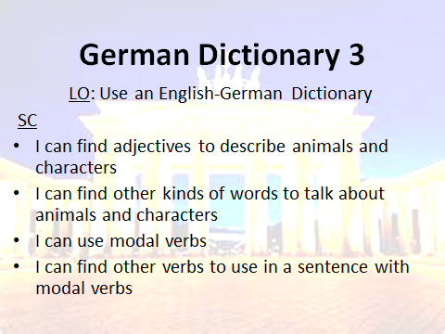 **Datum**





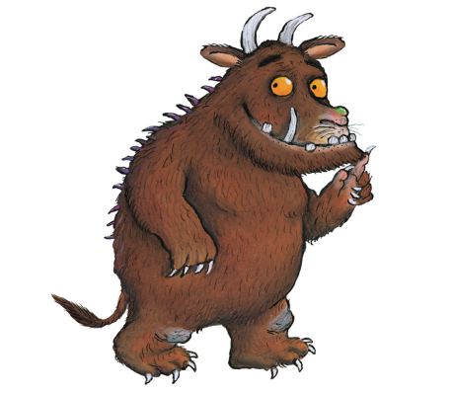[](http://www.google.co.uk/url?sa=i&rct=j&q=&esrc=s&source=images&cd=&cad=rja&uact=8&ved=0ahUKEwjwl57KmoHUAhWRDBoKHaXXClQQjRwIBw&url=http://uvassociates.in/3d-borders/yellow-elegant-fabric-fold-embossed-frame-rectangular-powerpoint-border&psig=AFQjCNEBF4t4bvaZgZslGiWFCL4O6KBO-g&ust=1495463592124418)

1. ____________________________________________________________________________________________________________________________________________________________________
2. ____________________________________________________________________________________________________________________________________________________________________
3. ____________________________________________________________________________________________________________________________________________________________________
4. ______________________________________________________________________________________________________________________________________________________________________________________________________________________________________________________

[](http://www.google.co.uk/url?sa=i&rct=j&q=&esrc=s&source=images&cd=&cad=rja&uact=8&ved=0ahUKEwjwl57KmoHUAhWRDBoKHaXXClQQjRwIBw&url=http://uvassociates.in/3d-borders/yellow-elegant-fabric-fold-embossed-frame-rectangular-powerpoint-border&psig=AFQjCNEBF4t4bvaZgZslGiWFCL4O6KBO-g&ust=1495463592124418)

1. ____________________________________________________________________________________________________________________________________________________________________
2. ____________________________________________________________________________________________________________________________________________________________________
3. ____________________________________________________________________________________________________________________________________________________________________
4. ______________________________________________________________________________________________________________________________________________________________________________________________________________________________________________________

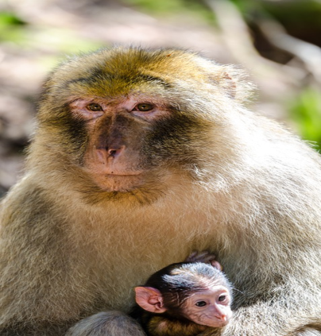

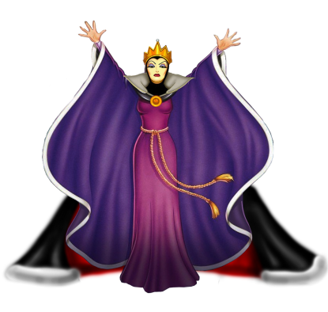[](http://www.google.co.uk/url?sa=i&rct=j&q=&esrc=s&source=images&cd=&cad=rja&uact=8&ved=0ahUKEwjwl57KmoHUAhWRDBoKHaXXClQQjRwIBw&url=http://uvassociates.in/3d-borders/yellow-elegant-fabric-fold-embossed-frame-rectangular-powerpoint-border&psig=AFQjCNEBF4t4bvaZgZslGiWFCL4O6KBO-g&ust=1495463592124418)

1. ____________________________________________________________________________________________________________________________________________________________________
2. ____________________________________________________________________________________________________________________________________________________________________
3. ____________________________________________________________________________________________________________________________________________________________________
4. ______________________________________________________________________________________________________________________________________________________________________________________________________________________________________________________

[](http://www.google.co.uk/url?sa=i&rct=j&q=&esrc=s&source=images&cd=&cad=rja&uact=8&ved=0ahUKEwjwl57KmoHUAhWRDBoKHaXXClQQjRwIBw&url=http://uvassociates.in/3d-borders/yellow-elegant-fabric-fold-embossed-frame-rectangular-powerpoint-border&psig=AFQjCNEBF4t4bvaZgZslGiWFCL4O6KBO-g&ust=1495463592124418)

1. ____________________________________________________________________________________________________________________________________________________________________
2. ____________________________________________________________________________________________________________________________________________________________________
3. ____________________________________________________________________________________________________________________________________________________________________
4. ______________________________________________________________________________________________________________________________________________________________________________________________________________________________________________________



[](http://www.google.co.uk/url?sa=i&rct=j&q=&esrc=s&source=images&cd=&cad=rja&uact=8&ved=0ahUKEwjwl57KmoHUAhWRDBoKHaXXClQQjRwIBw&url=http://uvassociates.in/3d-borders/yellow-elegant-fabric-fold-embossed-frame-rectangular-powerpoint-border&psig=AFQjCNEBF4t4bvaZgZslGiWFCL4O6KBO-g&ust=1495463592124418)

1. ____________________________________________________________________________________________________________________________________________________________________
2. ____________________________________________________________________________________________________________________________________________________________________
3. ____________________________________________________________________________________________________________________________________________________________________
4. ______________________________________________________________________________________________________________________________________________________________________________________________________________________________________________________
5. ____________________________________________________________________________________________________________________________________________________________________
6. ____________________________________________________________________________________________________________________________________________________________________
7. ____________________________________________________________________________________________________________________________________________________________________
8. ______________________________________________________________________________________________________________________________________________________________________________________________________________________________________________________
9. ____________________________________________________________________________________________________________________________________________________________________
10. ____________________________________________________________________________________________________________________________________________________________________
11. ____________________________________________________________________________________________________________________________________________________________________
12. ______________________________________________________________________________________________________________________________________________________________________________________________________________________________________________________

