die Maus | the mouse
das Insekt | the insect
das Zebra | the zebra
der Affe | the monkey
die Schildkröte | the turtle
die Eule | the owl
die Spinne | the spider
der Seehund | the seal
der Mensch | the human
das Eichhörnchen | the squirrel
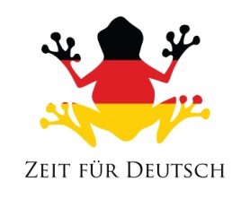
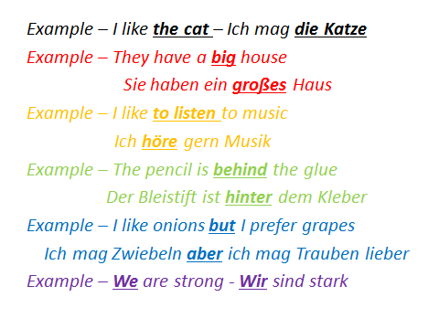
New Animals

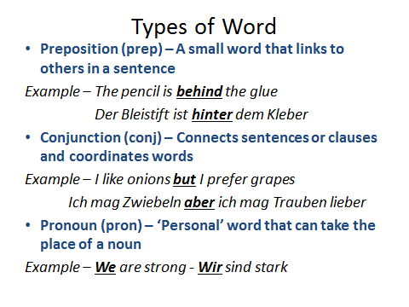
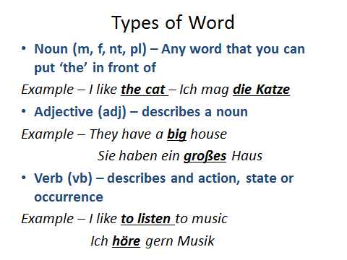

German Word | Type of Word | English Translation
Freund
amüsant
sprechen
ohne
es
oder
Klasse
(trick question)

English to German
English Word | Type of Word | German Translation
The dolphin
to want
since
something
happy
but
The money

Animals and Adjectives
The ……… is ………
