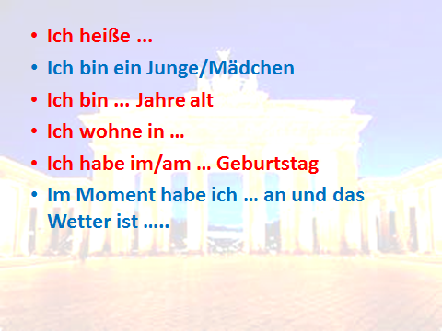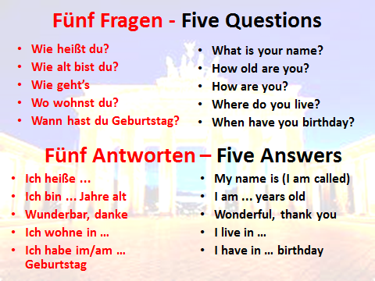

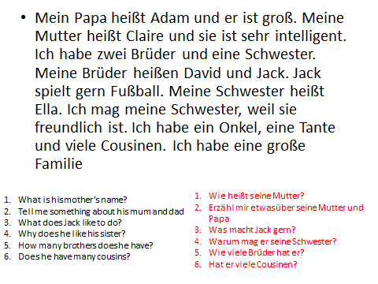



**__________________________________________________________________________________________________________________________________________________________________________________________________________________________________________________________________________________________________________________________________________________________________________________________________________________________________________________________________________________________________________________________________________________________________________________________________________________________________________________________________________________________________________________**

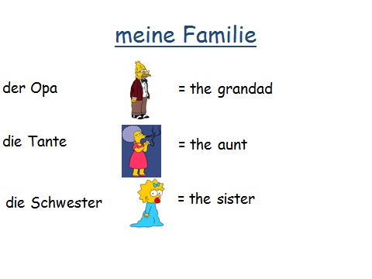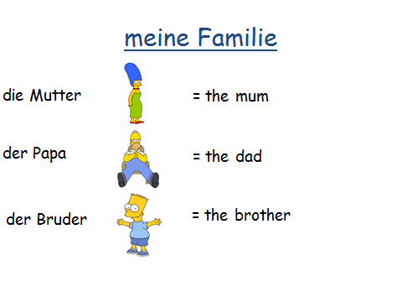

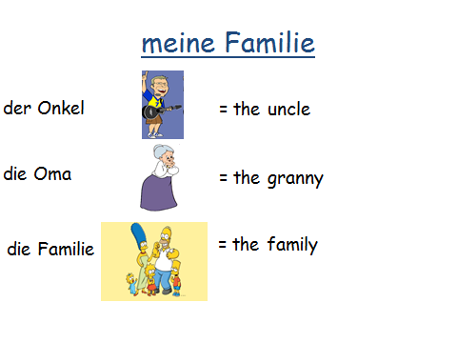

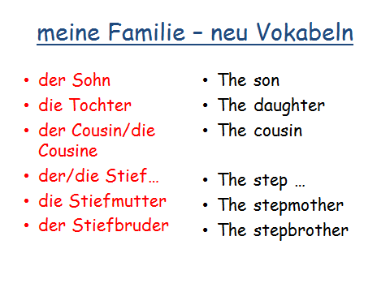

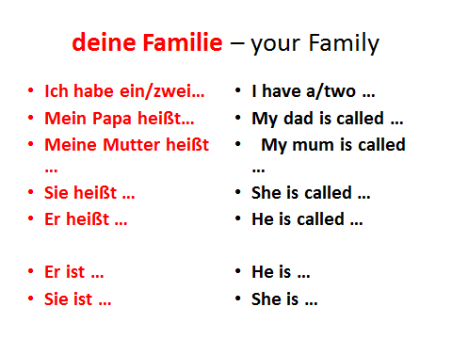

Useful Vocabulary

sonning – sunny

heiß - hot

warm - warm

kalt - cold

eiskalt - icy cold

windig - windy

wolkig - cloudy

neblig – foggy

sehr - very

intelligent - intelligent

heißen - are called

weil - because

freundlich - friendly

viele - lots of