

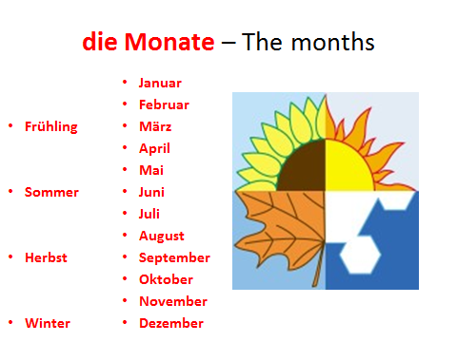

[](http://www.google.co.uk/url?sa=i&rct=j&q=&esrc=s&source=images&cd=&cad=rja&uact=8&ved=0ahUKEwidvsX9qdTKAhUG0xoKHWhbCY4QjRwIBw&url=http://www.nviroinsurance.co.uk/Contact_Us/&psig=AFQjCNFvwHEK3Mlbs5qvoYOpMavOdWJ-Lw&ust=1454339190404706)