Meine Schwester

[](http://blogs.timesofindia.indiatimes.com/wp-content/uploads/2014/07/42-60323787.jpg)



Meine Oma

[](http://www.google.co.uk/url?sa=i&rct=j&q=&esrc=s&source=images&cd=&cad=rja&uact=8&ved=0ahUKEwjWwJjMufzKAhXG0xQKHaCcAn8QjRwIBw&url=http://www.lancashiretelegraph.co.uk/news/13784500.Cinema_and_shopping_centre_plan_a_step_closer_for_town_centre/&bvm=bv.114195076,d.d24&psig=AFQjCNHWaYETEBIbVyyefZIoAnDwvfh7kw&ust=1455717811867715)



Meine Mutter

[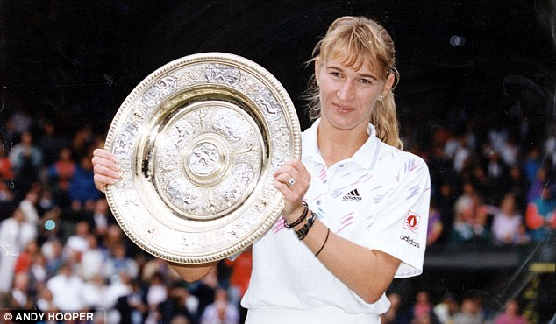](http://www.google.co.uk/url?sa=i&rct=j&q=&esrc=s&source=images&cd=&cad=rja&uact=8&ved=0ahUKEwjU0r7_svzKAhVJuhQKHRhsDvoQjRwIBw&url=http://www.dailymail.co.uk/sport/tennis/article-2568482/Hall-Fame-Steffi-Graf-Queen-court-greatest-sportswoman.html&psig=AFQjCNFoXwf8SBpK1luShreiSeZMkXq3BA&ust=1455716011087354)

Meine Tante

[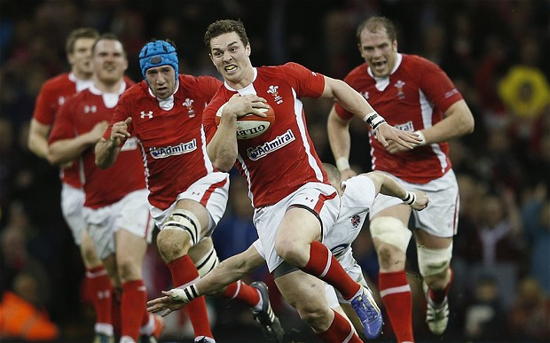](http://www.google.co.uk/url?sa=i&rct=j&q=&esrc=s&source=images&cd=&cad=rja&uact=8&ved=0ahUKEwjZgdHds_zKAhUMbhQKHVYsD90QjRwIBw&url=http://www.telegraph.co.uk/sport/rugbyunion/international/wales/10210820/Wales-can-win-2015-Rugby-World-Cup-insists-Sir-Clive-Woodward-the-mastermind-behind-Englands-triumph.html&bvm=bv.114195076,d.d24&psig=AFQjCNH-DAbzbCY1EpgjHZ-hr6UGYfBYkQ&ust=1455716167167308)



Mein Opa

[](http://www.google.co.uk/url?sa=i&rct=j&q=&esrc=s&source=images&cd=&cad=rja&uact=8&ved=0ahUKEwj7q6KBtvzKAhVKbRQKHTVQAN0QjRwIBw&url=http://www.sheknows.com/living/articles/989943/child-technology-geniuses&bvm=bv.114195076,d.d24&psig=AFQjCNF6uPtw60nN_8diMHGVa02YNx5PNw&ust=1455716810828572)

Mein Papa

[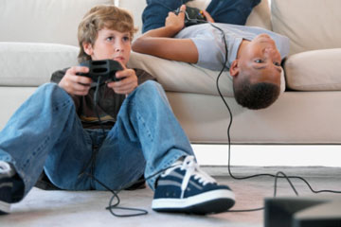](http://www.google.co.uk/url?sa=i&rct=j&q=&esrc=s&source=images&cd=&cad=rja&uact=8&ved=0ahUKEwieoPa9t_zKAhWLcRQKHV4dB4oQjRwIBw&url=http://onhd.xyz/c/children-playing-video-games-kids-playing-computer.html&bvm=bv.114195076,d.d24&psig=AFQjCNFfyfgZ0qyHQlcIb0LT0wd6uspTaw&ust=1455717183603359)

Mein Onkel

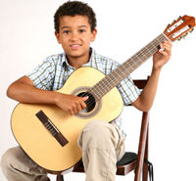



Mein Bruder



